Analog Engine
Example Applications
This document includes examples of applications realized with an analog engine. The scripting language used is described in the document “Analog Engine Scripting Language”.
Author: Dietmar Hiller
License: CC BY-NC-SA 4.0 (https://creativecommons.org/licenses/by-nc-sa/4.0/ )

Version History
‍2024-02-01 | Harmonic Oscillator basics | Dietmar Hiller
‍2024-01-31 | corrected 10¹ is da (deca)  License CC BY-NC-SA  Application: 2 raindrops | Dietmar Hiller
‍2024-01-24 | Some general details  Mass at the apex on a sphere | Dietmar Hiller
‍2024-01-16 | Added: Mass with charge in e/m field | Dietmar Hiller
2024-01-08 | Separated Helper Functions and Scaling to “Technical Topics”  Moved code to separate files AESL  Analytical solution of the damped harmonic oscillator  Scaling amplitude and time | Dietmar Hiller
2023-10-06 | Adapt to updated syntax: OUT.U  use of ALIAS  corrected usage of operation time: OP-TIME instead of SPEED | Dietmar Hiller
2023-10-04 | Added damped harmonic oscillator | Dietmar Hiller
2023-09-24 | First draft | Dietmar Hiller
Table of Content
1. Version History 1
2. Example Applications 2
2.1. Radioactive Decay 2
2.2. Harmonic Oscillator 2
2.2.1. Undamped 2
2.2.2. Damped 3
a) Analytical Solution 3
b) Scaling 4
2.3. Mass with charge in em field 6
2.4. Mass at the apex on a sphere 7
2.4.1. Equations of motion 7
2.4.2. Calculating λ 7
2.4.3. Final equations of motion 8
2.4.4. Program 8
2.5. Two raindrops 9
2.5.1. Scaling 9
2.5.2. Measurement 9
3. Notes 10

Example Applications

Radioactive Decay
N’ = -lambda * N
+1 -> InitialValue -> N0
N’, IC:N0 -> INTEGRATOR -> -N
-N -> Decay -> -lambda*N=N’
-N -> INVERTER -> N

Note that the integrator is inverting the sign and that the initial condition has the same sign as the input.
Full code see “Radioactive Decay.AESL”

Harmonic Oscillator

Undamped
A mass m is subject to a force .
- What is its trajectory if the mass starts at position (a,0,0)?
- At which time does it pass through (0,0,0)?
- What is its trajectory if it has additionally the initial speed (0,v0,0)?
The equation of motion is

z can be set to zero.
The application is straight forward, see “TP1 04.12 Harmonic Oscialltor.AESL”.
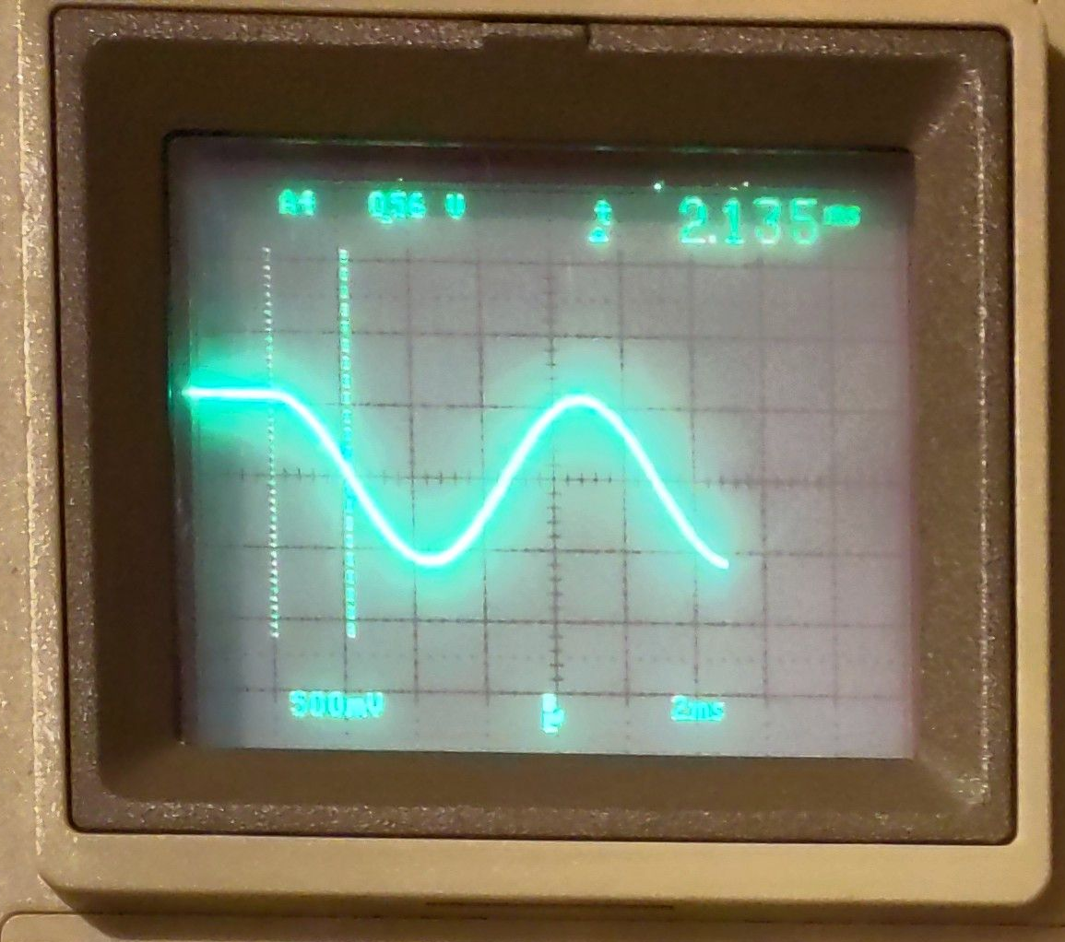
k/m is arbitrarily set to 0,541, a to 0,568.
- The trajectory is a sine oscillation.
- It passes through (0,0,0) at 2,135 s (timebase is 1 ms which corresponds to 1 s of the application).
This is in accordance to the calculated value of .
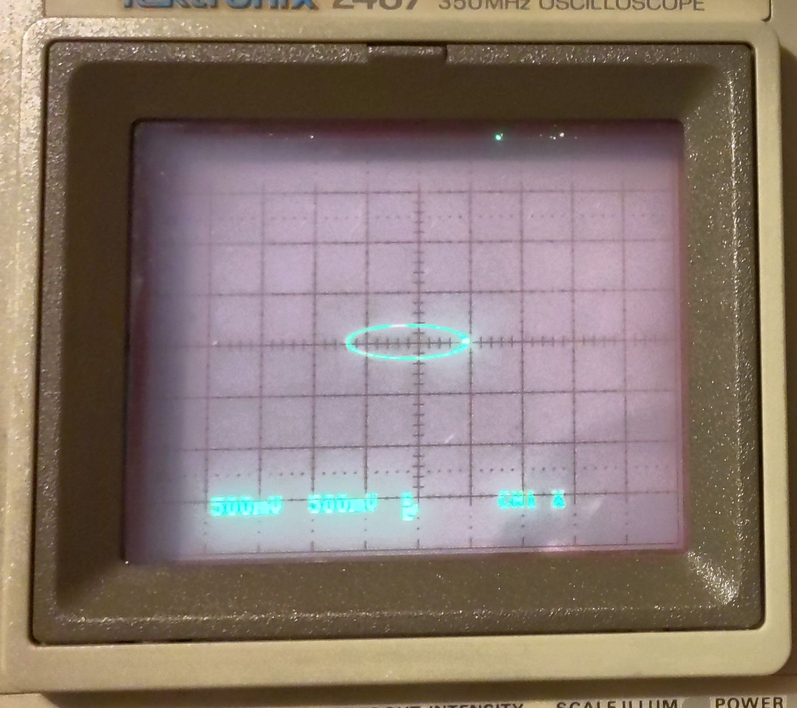
- It is ellipsoidal. Here v0=0,122 was used.

Damped
The equation of motion for a viscously damped simple harmonic oscillator is , with m the mass, D the damping with speed and S the spring constant.
Rewritten to y’’=-1/m * (Dy’+Sy).
An initial condition is required; we put the deflection to y0 and the speed to y0’.
Full code see “Damped Harmonic Oscillator.AESL”

Analytical Solution
[https://brilliant.org/wiki/damped-harmonic-oscillators/ ]
Solutions of the viscously damped simple harmonic oscillator should be oscillations within some form of damping envelope. Ansatz is an exponential damping envelope of an oscillation:

where A is some constant and (r = ai-g) will be found. g and a are place holders to show the damping (g) and oscillation (a). Plugging this ansatz into the equation of motion yields:

which is a quadratic equation in r with solutions:

Note that there are two roots r to the quadratic corresponding to the two general solutions:

These solutions in general describe oscillation at frequency within a decay envelope of time-dependent amplitude .
Note, the frequency of the oscillations is only depending on the spring constant, damping and mass, whereas the damping also depends on the mass.
For the undamped case (D=0) this gives

This can also be written as

Scaling
As an example, we may use the following data for the damped harmonic oscillator:
Initial Position | y0 | 1,5 m
Initial Speed | y0’ | -0,15 m/s
Spring Force | S | 2,5 N/m | kg/s²
Damping | D | 0,3 N/(m/s) | kg/s
Mass | m | 0,06 kg
 | 1/m | 16,667 kg⁻¹
Critical values are initial position (1,5 m) and 1/m (16,667 kg⁻¹). Spring force could be coped with by using a gain 10 input.
Please see the table below while following the description of the following steps.
First we take care of y0. We replace the length measured in meter with 10¹ meter, thus we make use of deca-meter. y0 and y0’ have to be adapted. See columns “deca-m” below. Spring Force and Damping remain unchanged because in base units the length gets canceled out.
Next issue is that 1/m is well above 1. We are representing the weight by 10⁻² kg, so 10¹ grams (deca-g). See columns “deca-g”. This also influences spring force and damping, which now exceed our target range.
Now, the second is replaced by 10⁻¹ (deci-s) seconds resulting in the columns “deci-s”. Note that this also performs time-scaling, so that one time-unit of the analog engine now corresponds to one deci-second instead of one second before.
After the last scaling we have the issue that y0’ is very close to zero. There are more advanced scaling techniques which manage to optimize the value range of each operational amplifier. For instance the initial speed is converted to a value very close to zero, which is not the optimal.
The fully scaled program can be found at “Damped Harmonic Oscillator scaled.AESL”. Note that the gain 10 inputs are used for SUMMER.2 in order to achieve damping and spring constant values:

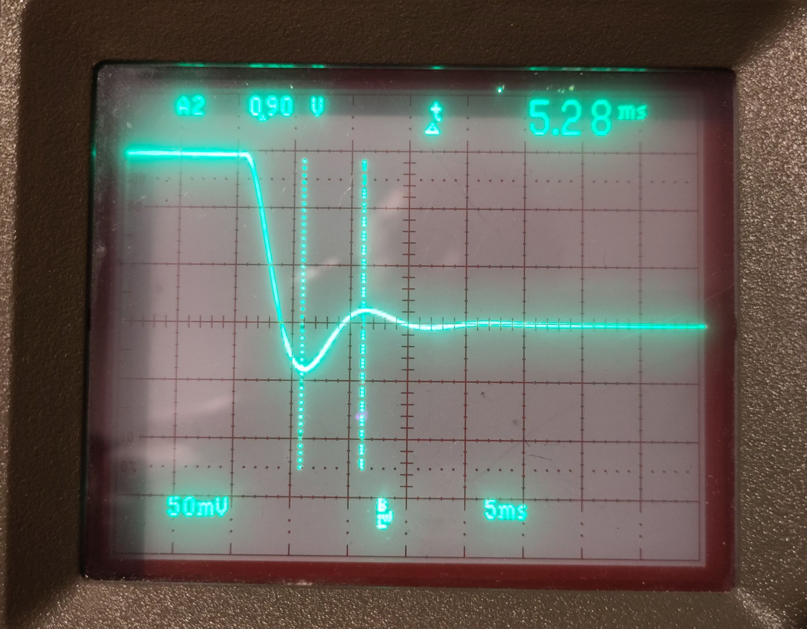Obtained damped oscillation with parameters above
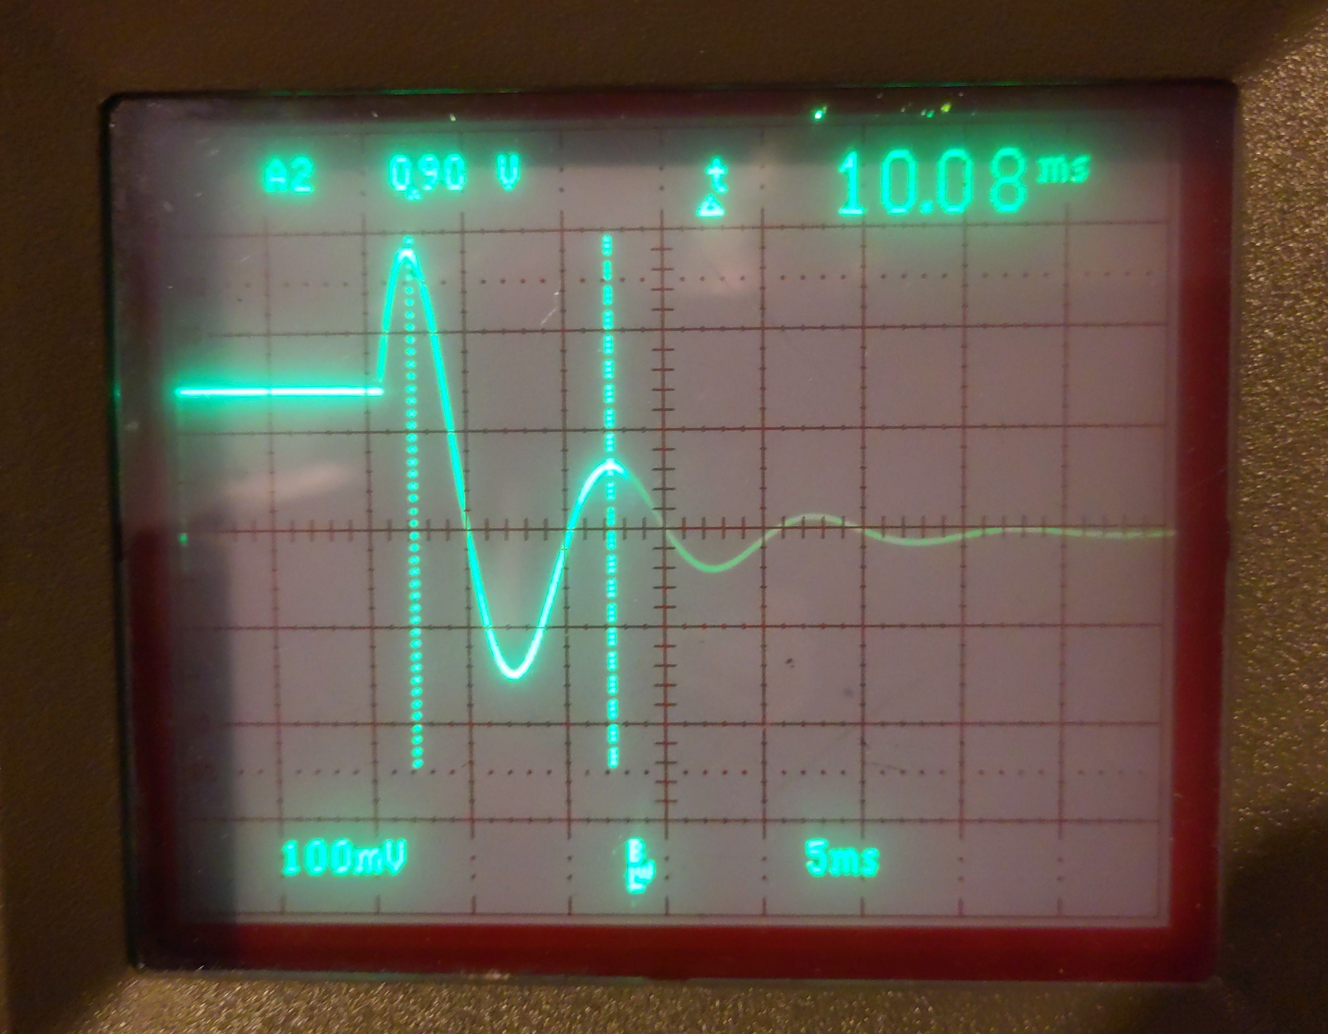Adapted parameters: D=1,69, y0'=-0,187; calculated T=9,97 ms

Mass with charge in em field
A mass m with charge q>0 is located in a static electro-magnetic field [0,0,E], [0,-B,0]. Calculate the trajectory of the mass. The Lorentz-force is causing the motion of the mass.
.
Which results in the two differential equations

with the solutions

This is the trajectory of a cycloid.
The AESL-program can be found in file “TP1 03.08 Charge in em field.AESL”.
It is interesting and easy to play with initial speed conditions.
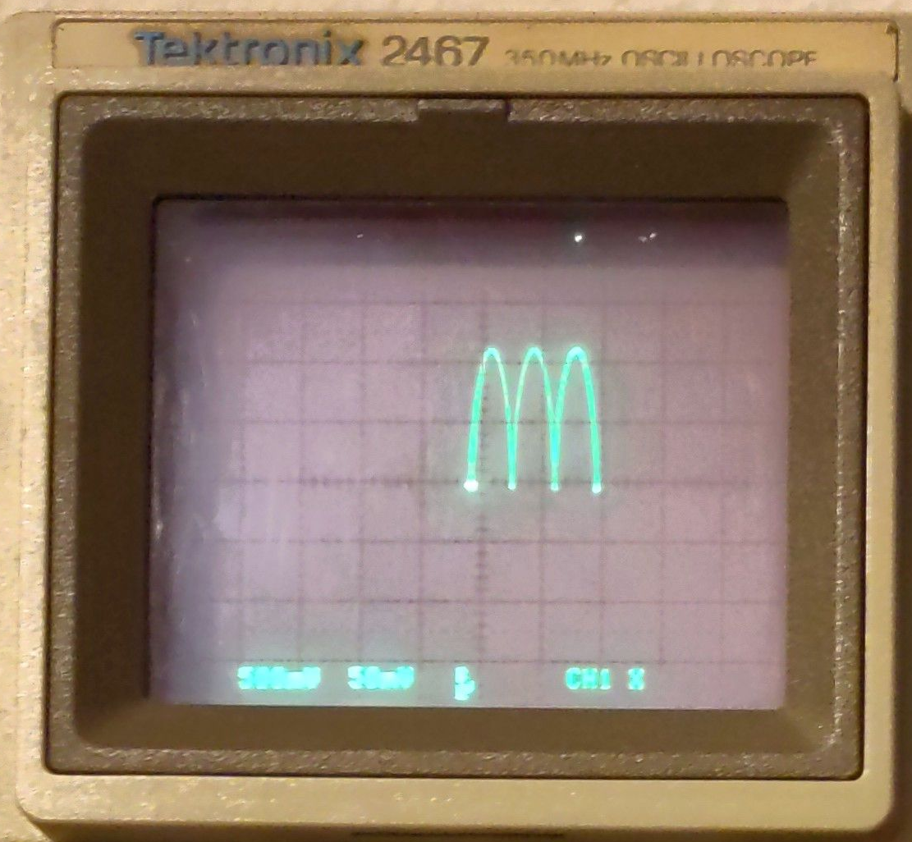Trajectory of a charge mass in an em field (omega=0,92; a*omega²=0,05; OP-time=0,21ms) | 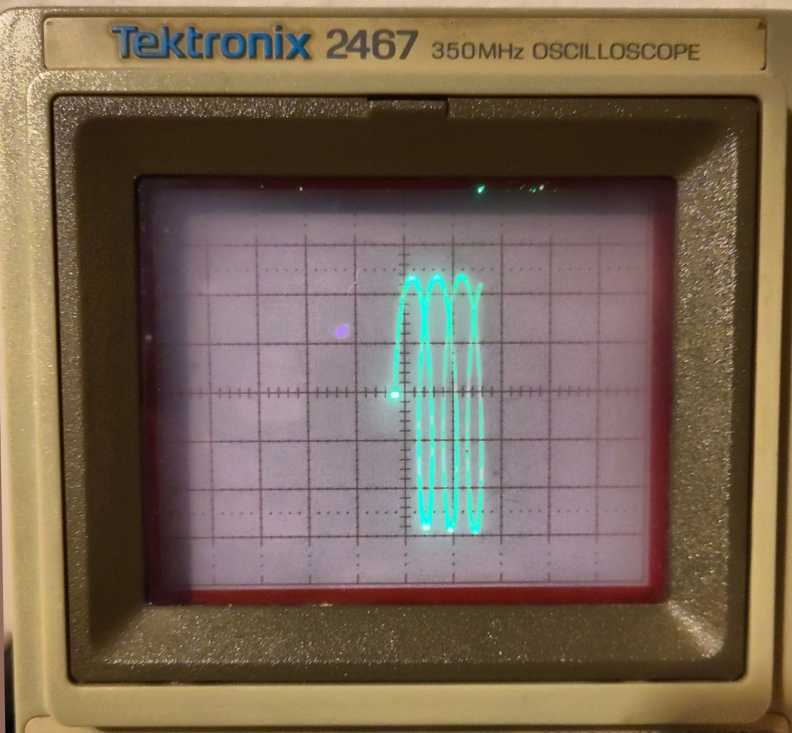Added initial speed in x and z-direction

Mass at the apex on a sphere
A mass m rests at the apex on a fixed sphere with radius a. With a slight displacement, it slides down the sphere without friction.
We are making use of Lagrange equations of the 1st kind.

Equations of motion

Calculating λ
Insertion of the equations of motion

v² is determined by the law of conservation of energy

Final equations of motion

Program
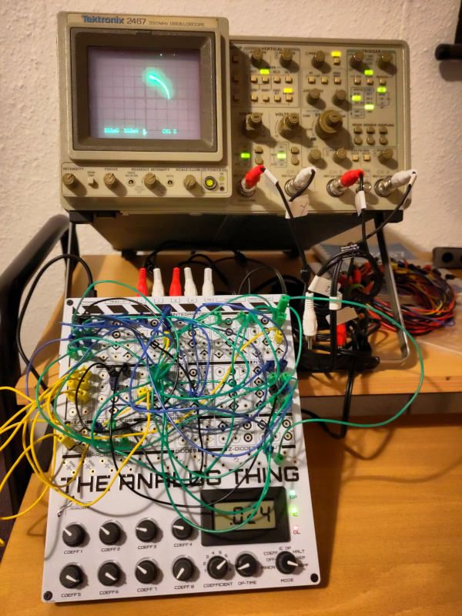
Scaling is done simply by using da-m (10¹ m) instead of meter in order to have g=0,981 da-m/s². Thus also a, x, y are measured in da-m. The constants are thus:
‍Const | Coefficient | Example | Unit
a |  | 1,000 | da-m
g | C5 | 0,981 | da-m / s²
3 g / a² | C1 (for x*y), C2 (for y^2) | 2,943 | 1 / (da-m * s²)
2 g / a | C3 (for x), C4 (for y) | 1,962 | 1 / s²
x0 | C6 (=root(a² – y0²)) | 0,957 | da-m
y0 | C7 | 0,290 | da-m
The display of the oscilloscope is extremely sensitive to these parameters and the tolerances of the potentiometers. E.g. C6=1 had to be set to get a good result.
The full program can be found in file
“TP1 04.10 MassOnSphere.AESL”

Two raindrops
Two raindrops of same size and altitude are falling towards the earth. How long does it take until they touch due to the gravitational force between them?
As this is a multi-body problem, we make use of the reduced mass (1/µ = 1/m₁ + 1/m₂). This gives the differential equation

With m₁=m₂: µ=m/2, with m=m₁=m₂ thus
.
The fact that the mass is divided by 2 can be understood by the fact that both raindrops are attracting each other, thus reducing inertia.

Scaling
Looking at the values for this calculation, the need for scaling is evident:
- Radius of the raindrops: r=1mm
- Initial distance: 2 mm
- Constant of gravity: γ=6,672*10⁻¹¹ m³/(kg s²)
- Density of water: ρ=1 kg / dm³
- Mass: m=4π/3*ρ*r³=4,189*10⁻⁶ kg

First, cm are used for the lengths, which also puts the size of the drops to a usable value. However, the constant of gravity still remains too small. Next, time is measured in 10⁴ s.

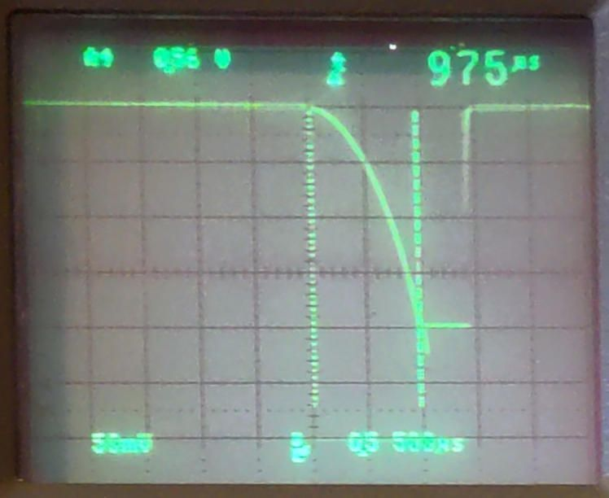
Which gives the settings:
- 2r 0,200 cm
- s0 0,400 cm
- 2gamma*m 0,056 cm³/(10^4 s)²
Timescale is: 1 Timebase = 10⁴ s

Measurement
The time until the two drops touch is measured to 975 µs.
Timebase of THAT is 1 ms, thus the measured time is 10⁴ s * 0,975 ms / 1 ms = 9750 s = 2,71 h, which corresponds to the calculated value.
AESL-Script: “TP1 04.11 TwoRaindrops.AESL”

Notes
Useful links:
- Solve differential equations: https://www.wolframalpha.com
- Calculate derivatives: https://www.ableitungsrechner.net/

